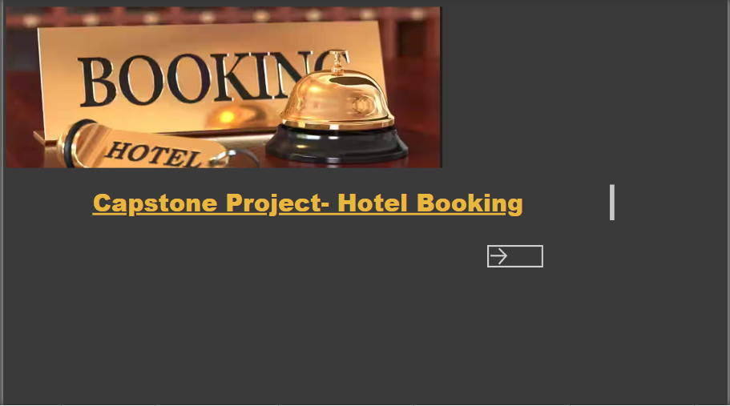

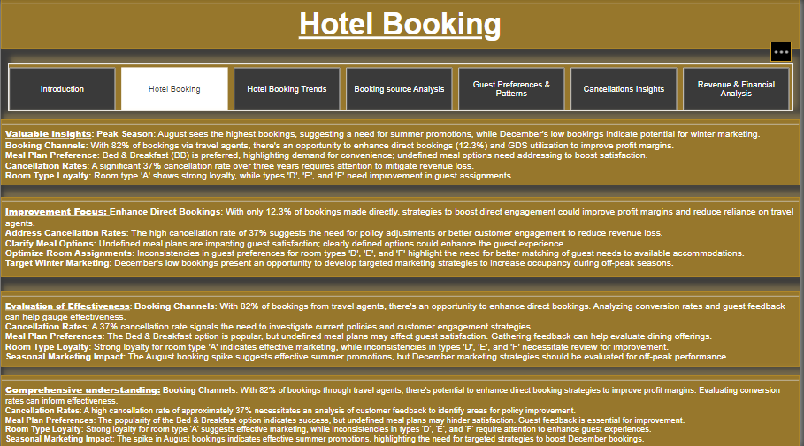

|  |
| --- |
| **Objective: The objective of this project is to create a comprehensive Power BI dashboard utilizing the given hotel booking dataset. The dashboard will visually analyse key metrics such as booking trends, channel performance, cancellation rates, meal plan preferences, and room type loyalty. By transforming raw data into actionable insights, the goal is to enhance decision-making capabilities, identify areas for improvement, and drive strategic marketing initiatives for the hotel.** |

|  |
| --- |
| **Analysis scope: The analysis scope encompasses a thorough examination of the hotel booking dataset to derive actionable insights and enhance operational strategies. Key focus areas include identifying booking patterns across different channels, assessing guest preferences for room types and meal plans, and evaluating the impact of cancellation rates on revenue. The analysis will explore seasonal trends in bookings to inform marketing strategies and promotional efforts. Additionally, a detailed evaluation of guest demographics will provide insights into the composition of bookings, allowing for tailored service offerings. The effectiveness of existing booking sources will be assessed to enhance direct booking strategies and optimize revenue generation. Overall, the analysis aims to create a comprehensive understanding of the factors influencing hotel bookings and guest satisfaction, ultimately leading to improved decision-making and operational efficiency.** |

|  |
| --- |
| **Goal: The goal of this project is to develop a comprehensive Power BI dashboard that effectively visualizes and analyses the hotel booking dataset, enabling stakeholders to make informed decisions based on key insights. This includes identifying trends in booking patterns, understanding guest preferences, and analysing factors contributing to cancellations. By leveraging data visualization techniques, the dashboard aims to enhance operational efficiency, optimize marketing strategies, and improve guest satisfaction. Ultimately, the project seeks to provide actionable recommendations that drive revenue growth and foster a better guest experience in the hotel industry.** |

|  |
| --- |
| **Insights and Recommendations: The Power BI dashboard will generate valuable insights to analyse booking patterns, guest preferences, and factors influencing cancellations. By visualizing data trends and identifying peak booking periods, it will support strategic marketing decisions, especially for enhancing summer promotions and boosting off-peak reservations. The dashboard will also help assess the effectiveness of booking channels, revealing opportunities to increase direct bookings and improve profit margins. Additionally, it will provide insights into meal plan preferences and guest demographics, allowing for tailored offerings that enhance customer satisfaction. Ultimately, this comprehensive analysis will drive informed decisions to optimize hotel operations and revenue management.** |

|  |
| --- |
| **Report and Presentation: The final deliverable will consist of a detailed report describing the data source, data modelling, methodologies, and data cheansing process used in creating Power bi dashboard. The report will include step by step guide on how to interpret the insights and the use of dashboard in decision making. The presentation will showcase the key findings, visualisations, and actionable recommendations derived from the dashboard’s analysis.** |

|  |
| --- |
| **The Power BI dashboard, along with the accompanying report and presentations, will serve as a powerful tool for hotel booking analysis. It will empower decision-makers to optimize booking strategies, reduce cancellations, and enhance overall business performance in the competitive hotel market. By leveraging data-driven insights, hotels can effectively respond to guest preferences, improve customer satisfaction, and ultimately drive revenue growth.** |

ER Diagram

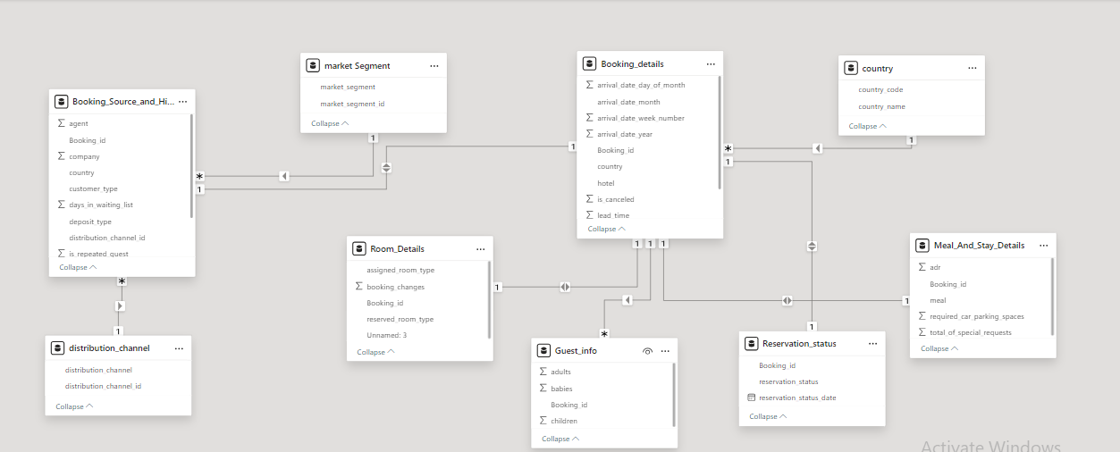

|  |
| --- |
| **Power BI Problem Statement** Pie chart with solid fill |

